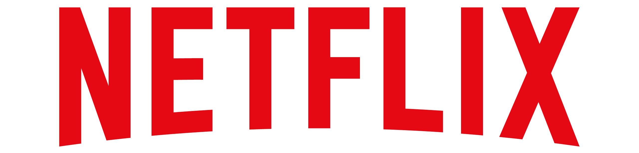
100 Winchester Circle Los Gatos, California 95032
866-716-0414 | https://about.netflix.com/en

News Release

FOR IMMEDIATE RELEASE FOR MORE INFORMATION:
August 27, 2021 Alexa Cash
Public Relations Practitioner
913-223-2406
alexacash4@gmail.com

LOS GATOS, Calif. – Netflix, Inc. (NASDAQ: NFLX) announced today that it will celebrate its 24th anniversary with an in-person event and a new online feature for members. This past year has been difficult for everyone, and Netflix recognizes the impact it has had in allowing members to escape the hardships of the pandemic. To thank its loyal members who have supported Netflix for 24 years, Netflix is hosting “Because You Watched: A Netflix Exhibition,” featuring a new, personalized online opportunity called “Where It All Began.”

The “Because You Watched: A Netflix Exhibition” will be a free event from Aug. 27-29. The event will be at 7:30 p.m. PST at Raleigh Studios Hollywood, Stage 1 in Los Angeles, California. Netflix will be offering members the chance to step into their favorite Netflix Originals like “Stranger Things,” “Outer Banks,” “Bridgerton” and more. This event will give members the opportunity to explore the fictional worlds they have gotten to know on their screens in real life.

“The experience we offer is driven by continuous innovation in technology and responding to the desires of the people. What sets us above the rest is how we improve the quality of experience, which comes down to our attention to detail,” said Ted Sarandos, co-CEO of Netflix.

The “Where It All Began” online feature will launch on Netflix’s actual anniversary of Aug. 29 and give members the chance to reminisce on where their journey began with Netflix. Members will be given the option to revisit the very first series or film they viewed while also seeing their most-viewed series and film. This online feature will be presented to members on the home screen of a Netflix account. Just as Netflix will be reflecting on these past 24 years, members will get the same opportunity.

“After a year of stress, I can appreciate any opportunity to celebrate the little things in life,” said Luanne Simmons, manager of brand strategy at Netflix.

Founded on Aug. 29, 1997 in Los Gatos, California by Reed Hastings and Marc Randolph, Netflix has become an innovator in the entertainment industry. Hastings and Randolph had an idea to provide consumers with a variety of rental DVDs through the mail. This simple idea grew into one of the world’s leading online streaming platforms with over 203 million members. Netflix reaches over 150 countries in more than 30 languages and continuing to provide the world with entertainment through a simple click of a button.

About Netflix, Inc.
Netflix, Inc. (NASDAQ: NFLX) has released its second-quarter 2021 financial results by posting them to its website. Please visit the Netflix investor relations website at http://ir.netflix.net to view the Q2'21 financial results and letter to shareholders.
A video interview with Netflix co-CEO Reed Hastings, co-CEO & Chief Content Officer Ted Sarandos, Chief Financial Officer Spence Neumann, COO & Chief Product Officer Greg Peters and VP, IR & Corporate Development Spencer Wang will be available at 3:00 p.m. Pacific Time at youtube.com/netflixir. The interview will be conducted by Nidhi Gupta, Fidelity Management & Research Co. Questions that investors would like to see asked should be sent to nidhi.gupta@fmr.com.
Netflix is the world's leading streaming entertainment service with 208 million paid memberships in over 190 countries enjoying TV series, documentaries, and feature films across a wide variety of genres and languages. Members can watch as much as they want, anytime, anywhere, on any internet-connected screen. Members can play, pause and resume watching, all without commercials or commitments. For more information about Netflix, Inc., please visit the company’s website at about.netflix.com/en.

###

