Social Media Release- Netflix and the Coastal Conservation League Partnership Event

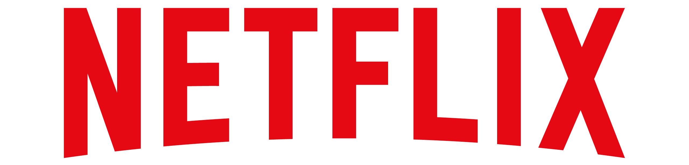
100 Winchester Circle Los Gatos, California 95032
866-716-0414 | https://about.netflix.com/en
Alexa Cash
Netflix Inc.
Email: alexacash4@gmail.com
Telephone Number: 913-223-2406
Address: 100 Winchester Circle Los Gatos, CA 95032
Business Website: about.netflix.com/en

Who
- Reed Hastings, Netflix Inc. founder, and co-CEO
- Ted Sarandos, Netflix Inc. co-CEO and chief content officer since July 16, 2020
- Dana Beach, The Coastal Conservation League founder
- Laura Cantral, The Coastal Conservation League executive director

What
- “Pogues 4 Life” an event where Netflix and the Coastal Conservation League team up to protect the nature of South Carolina and all its inhabitants
- Celebrity guests include the stars of “Outer Banks”: Chase Stokes, Madelyn Cline, Rudy Pankow, Madison Bailey and Johnathan Daviss

When
- Noon on Saturday, Aug. 21

Where
- James Island, South Carolina
Why
- To give back to the community of South Carolina that has given Netflix members both seasons of “Outer Banks”

Boilerplate:
“Netflix is the world's leading streaming entertainment service with 208 million paid memberships in over 190 countries enjoying TV series, documentaries, and feature films across a wide variety of genres and languages. Members can watch as much as they want, anytime, anywhere, on any internet-connected screen. Members can play, pause and resume watching, all without commercials or commitments.”

“The Coastal Conservation League is a nonprofit advocacy organization dedicated to protecting the coastal resources of South Carolina. Its mission is to protect the state’s natural landscapes, abundant wildlife, clean water, and quality of life. Since 1989, the Conservation League has carried out this mission by working with citizens, local government and the state legislature.”

Sources: https://mission-statement.com/netflix/ , https://about.netflix.com and https://www.coastalconservationleague.org

Quotes
- “We here at Netflix have been so excited about the success of “Outer Banks” and love that our members are enjoying it as much as us. We want to give back to the community of South Carolina, because they have given their little piece of paradise to us for two years. We are thrilled to be teaming up with the Coastal Conservation League to clean the shores of James Island and bring a couple familiar faces along,” said Ted Sarandos, co-CEO of Netflix.
- “The Coastal Conservation League is honored to be working alongside Netflix in maintaining the beauty of James Island in South Carolina. We believe that everyone has the ability to make decisions that lead to a better tomorrow. We are excited to give the public the opportunity to get involved in conservation and have fun while doing it,” said Laura Cantral, Executive Director of the Coastal Conservation League

Multimedia Links Section
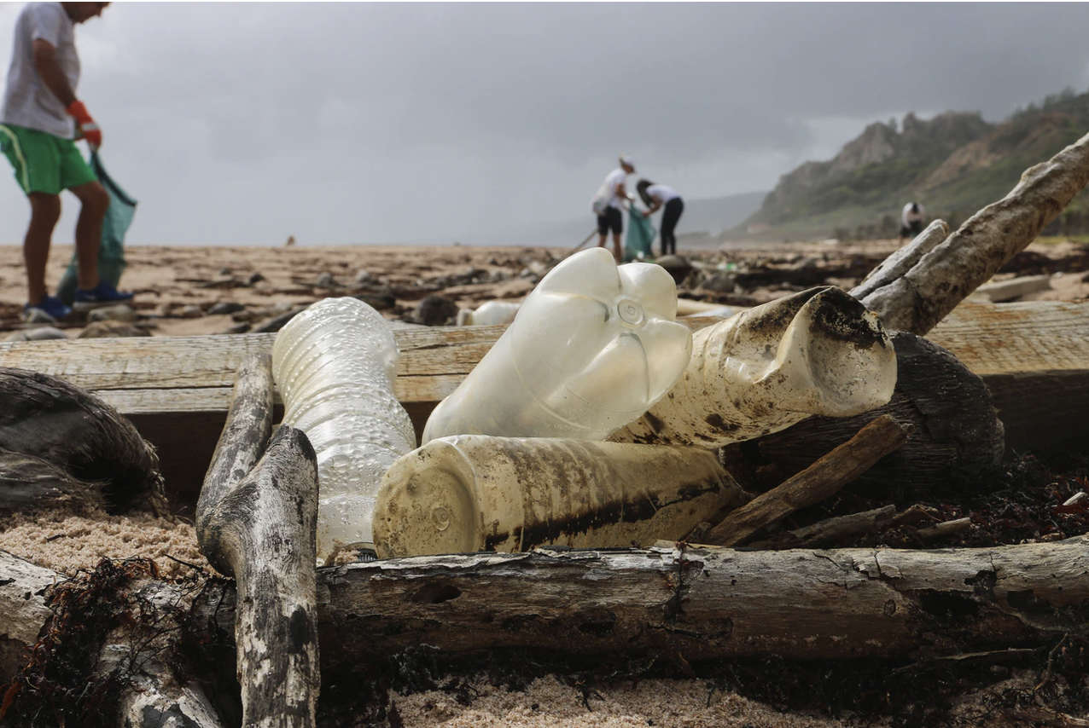
- High-Resolution Photos

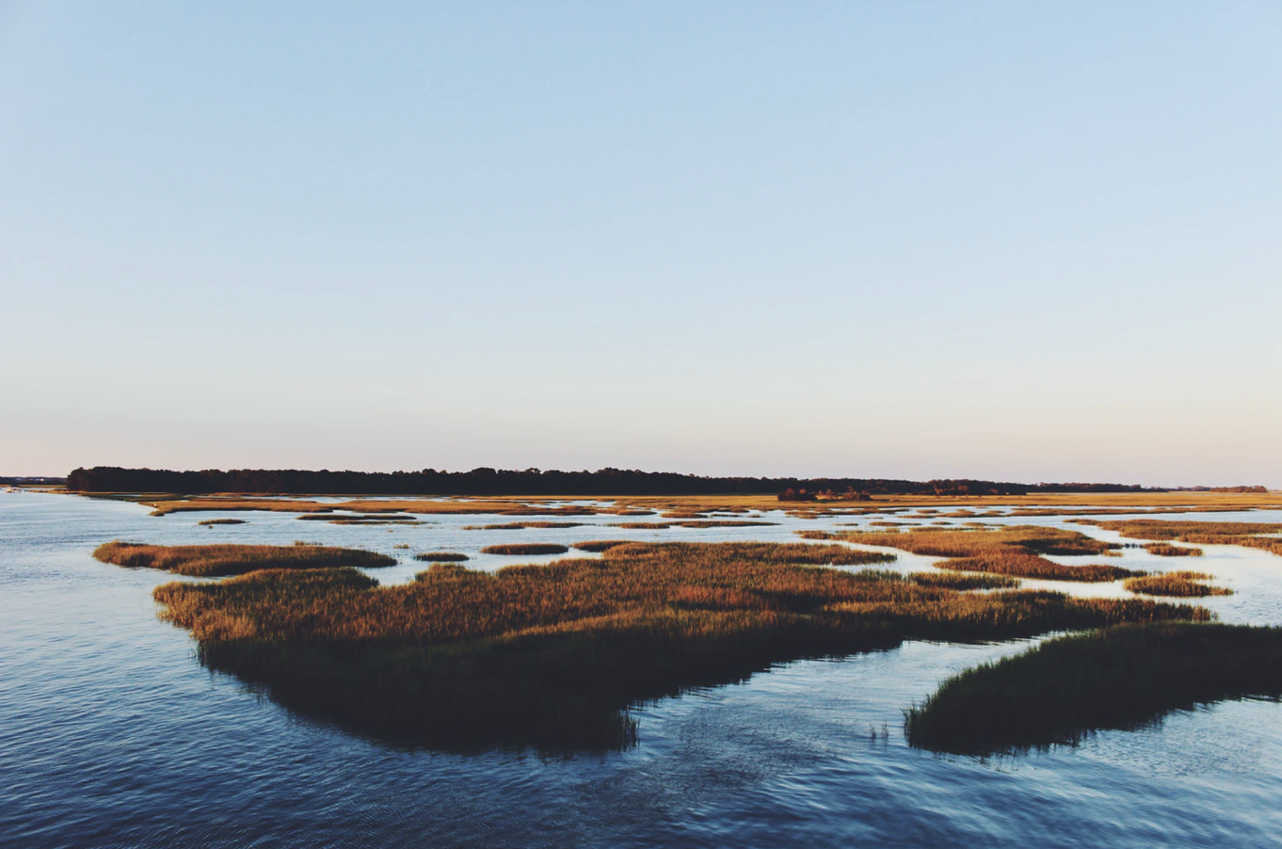
The beautiful marsh of South Carolina
The shores of James Island, South Carolina are littered with plastic bottles, but not for long…
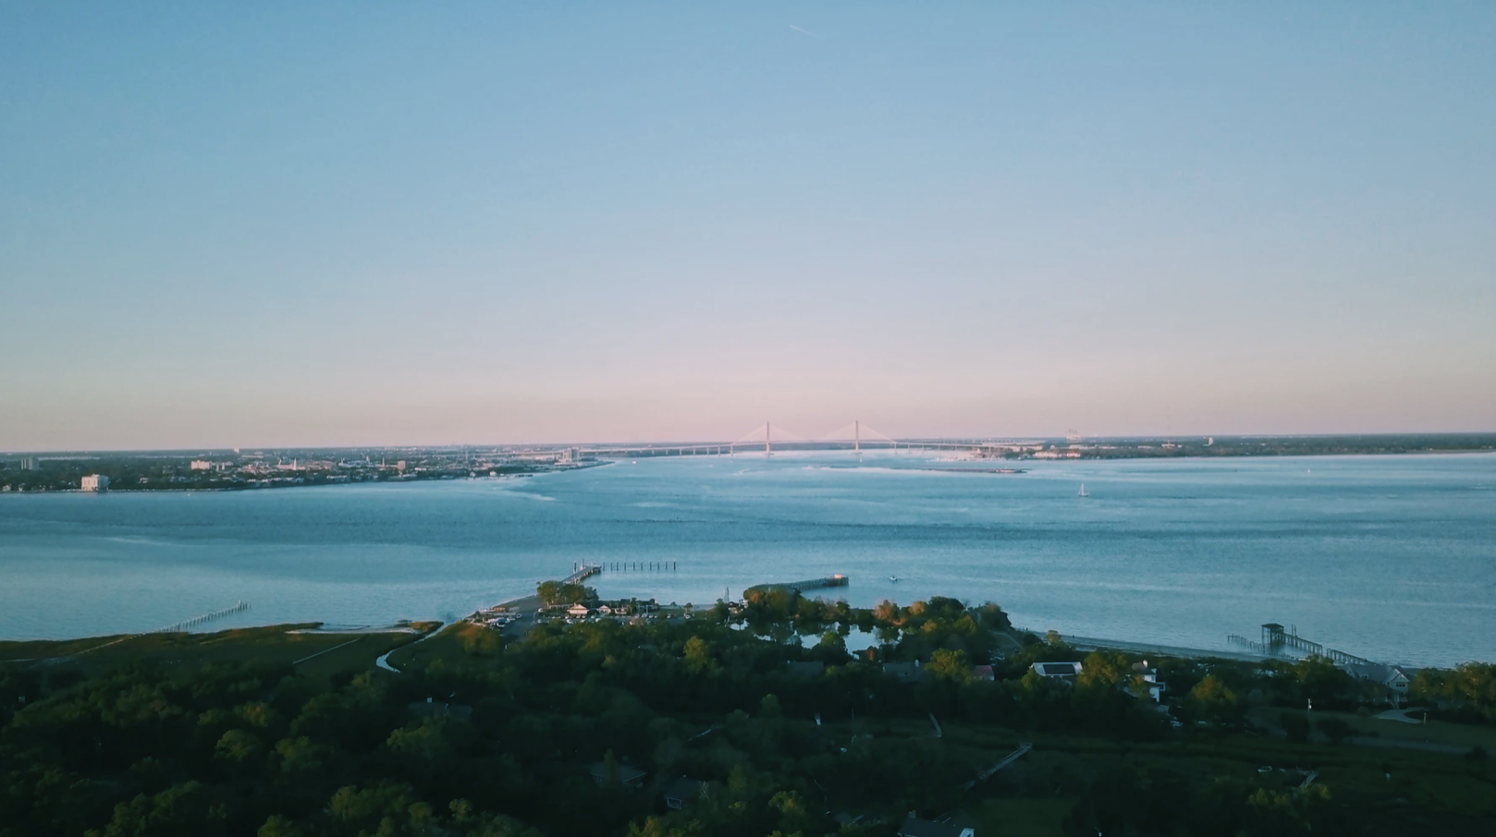
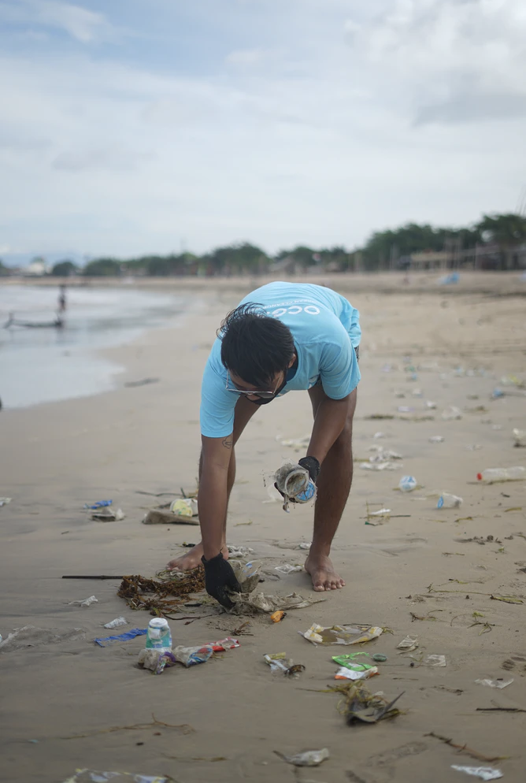
A stunning aerial shot of Charleston, South Carolina

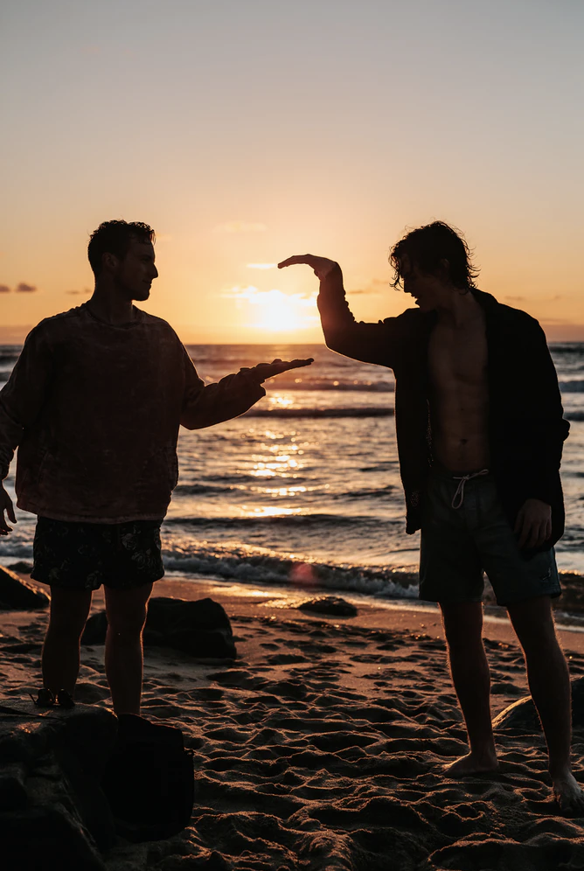

A local volunteer dedicating his Saturday to cleaning the shores of James Island at the “Pogues 4 Good” event.

Just two pogues high fiving after a day of doing good in James Island, South Carolina.

- Video Footage
  - The Coastal Conservation League- Charleston’s Comprehensive Plan via YouTube
- Netflix’s Social Media Platforms
  - Instagram Handle: @netflix
  - Twitter Handle: @netflix
- Additional Live Links
  - Netflix co-CEO and Chief Content Officer Ted Sarandos
  - The Coastal Conservation League Executive Director Laura Cantral
  - The Coastal Conservation League’s City of Charleston Comprehensive Plan

Social Media Posts

Instagram
@netflix
Caption: “Just two pogues high fiving after a day of doing good with the Coastal Conservation League in James Island, South Carolina! #P4L #Pogues4Good 🤟🛥🐠”

Twitter
@netflix

“POV: You’re cleaning up the shores of James Island, South Carolina with John B., Sarah Cameron, JJ, Pope and Kiara 😳😉”

Blog Post

“Pogues 4 Good” - A Netflix and the Coastal Conservation League Epic Partnership

“Ever since I came to Netflix Inc. in 2020, I knew I wanted to both continue Netflix’s mission of entertaining the world while simultaneously bettering the world as well. That being said, I am excited to announce an epic partnership with the Coastal Conservation League of Charleston, South Carolina. Our Netflix Original of “Outer Banks” season two was released to the world on July 30 and this got us here at Netflix thinking. The community of South Carolina has opened up their little piece of paradise to us for two years now and we want to give back.

On August 21, Netflix and the Coastal Conservation League will be hosting a joint event entitled “Pogues 4 Good” where you, the public will be invited to join us in maintaining the beauty of the James Island shore. A few familiar faces will also be attending the event, you might know them as John B., Sarah Cameron, JJ, Pope and Kiara. We will all be getting our hands dirty for good as we clean the shores of James Island and discuss the importance of sustainability and conservation. South Carolina has given so much to us and it is time we give back to them.

The event will be held at noon on August 21 at James Island, South Carolina – a ticket is needed for admission and can be bought here. All the ticket proceeds will go directly to the Coastal Conservation League, and goodie bags will be included with each purchase.

I am so thrilled to be hosting this event with a cause as worthy as the Coastal Conservation League and cannot wait to see you all there!”

-Ted Sarandos

