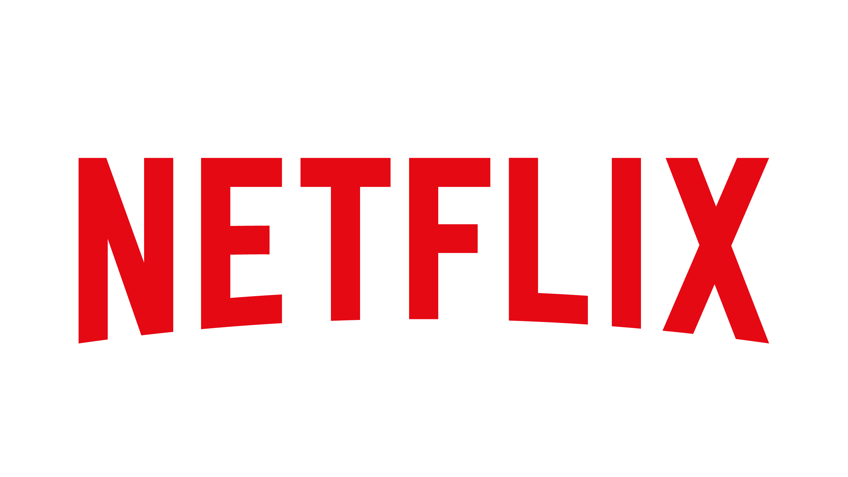
Alexa Cash
Netflix
Email: alexacash4@gmail.com
Telephone Number: 913-223-2406
Address: 100 Winchester Circle Los Gatos, CA 95032
Business Website: https://about.netflix.com/en

Fact Sheet: Netflix’s 24th Anniversary- Aug. 29

Who
- Reed Hastings, founder, and co-CEO
- Ted Sarandos, co-CEO and chief content officer since July 16, 2020

What
- Netflix’s 24th Anniversary
- An in-person event- “Because You Watched: A Netflix Exhibit”
- An online feature- “Where It All Began”

When
- “Because You Watched: A Netflix Exhibit”
- Time: 7:30 p.m. PST
- Date: Friday, Aug. 27 through Sunday, Aug. 29

Where
- “Because You Watched: A Netflix Exhibit” – Raleigh Studios Hollywood, Stage 1, Los Angeles, CA 90004
- “Where It All Began” – accessible at Netflix.com
Why
- “Where It All Began” - subscribers can see their most viewed series and films since their first day of subscription
- “Where It All Began” - first ever series or film viewed
- Relaunching of “Because You Watched: A Netflix Exhibit” - viewers get the opportunity to step into and immerse themselves in their favorite Netflix Originals

Benefits
- Subscribers can reflect on their journey with Netflix
- The “Because You Watched: A Netflix Exhibit” will be a free event (as supplies last)

Background on Netflix
- Vision Statement: “Becoming the best global entertainment distribution service.”
- Mission Statement: “We promise our customers stellar service, our suppliers a valuable partner, our investors the prospects of sustained profitable growth, and our employees the allure of huge impact.”
- Boilerplate: “Netflix is the world's leading streaming entertainment service with 208 million paid memberships in over 190 countries enjoying TV series, documentaries, and feature films across a wide variety of genres and languages. Members can watch as much as they want, anytime, anywhere, on any internet-connected screen. Members can play, pause and resume watching, all without commercials or commitments.”

Sources: https://mission-statement.com/netflix/ and https://about.netflix.com

