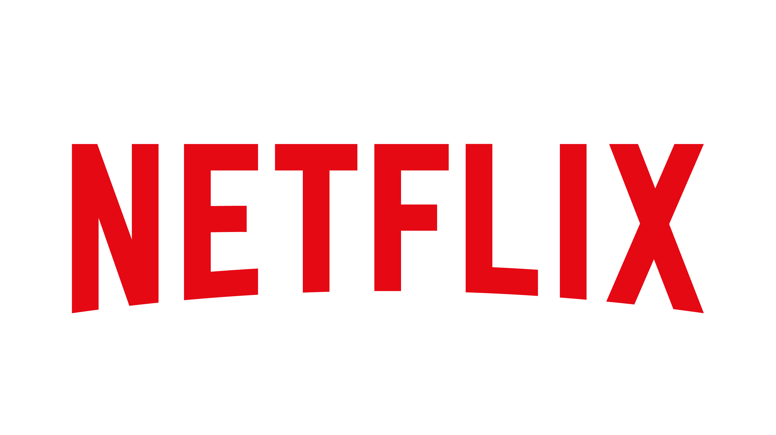

Alexa Cash
Netflix
Email: alexacash4@gmail.com
Telephone Number: 913-223-2406
Address:100 Winchester Circle Los Gatos, CA 95032
Business Website: about.netflix.com/en

[Netflix’s 24th Anniversary- August 27]

Netflix is an online streaming platform that reaches over 150 countries in more than 30 languages, providing the world with entertainment through TV shows, movies and documentaries. The headquarters for Netflix is located in Los Gatos, California with 14 offices located across 10 countries. Netflix was founded on August 29, 1997 when Reed Hastings and Marc Randolph had an idea to provide consumers with the ability to rent DVDs by mail.

By 2006 membership had grown to 5 million and a year later streaming was introduced, which allowed members to instantly watch their favorite films and series. In 2012, membership reached 25 million and Netflix’s reach expanded to Ireland, the United Kingdom, and the Nordic Countries. A year later Netflix released their own original series such as “House of Cards” and “Orange Is the New Black.” In just three years after, Netflix launched their first original feature film and, by 2016, Netflix expands to 130 new countries.

In 2017, Netflix hit 100 million members globally and in 2018 Netflix is the most-nominated studio at the Emmys. On July 16, 2020, Netflix appointed Ted Sarandos to co-CEO and Chief Content Officer. Now in 2021, Netflix has over 200 million members and releases its first-ever series and film diversity study, powered by USC Annenberg Inclusion Initiative. Netflix is a household name and continuing to diversify their content to provide stories for the world.

Netflix’s first inclusion report shared a look into their own representation, future plans and cultivation of an accepting community. The numbers showed that Netflix has continually outperformed top-grossing films in representation of underrepresented communities. For example, 37.9 % of Netflix films and 35.2 % of Netflix series feature underrepresented characters. The percentage of leads/co leads by racial/ethnic group in film and series is as follows: White (71.8%), Black/African American (13%), Hispanic/Latino (4.7%), Asian (2.3%), Middle Eastern/North African (1.3%), Multiracial/Multiethnic (3.3%), with American Indian/Alaskan Native and Native Hawaiian/Pacific Islander being too low to count.

Anniversary Event Details

Netflix will be celebrating 24 years of bringing entertainment into the lives of millions through “Where It All Began” allowing subscribers the opportunity to see their most viewed series and films since their first day of subscription. In addition, Netflix will be relaunching its “Because You Watched: A Netflix Exhibit,” where viewers get the opportunity to step into and immerse themselves in their favorite Netflix Originals.

Netflix’s global audience of 203 million members will be able to reflect on their journey with Netflix by getting to see where they began with the corporation. Members are given the opportunity to see their first series or film viewed, as well as their most revisited series and films. This feature will be presented to members on their initial home screen page.

The “Because You Watched: A Netflix Exhibit” will be a free event (tickets available while supplies last) held from Friday, August 27 to Sunday, August 29. The event will be held at Raleigh Studios Hollywood, Stage 1 in Los Angeles, California at 7:30 p.m. PST. Members will have the chance to step into the world of their favorite Netflix Originals like “Stranger Things,” “The Crown,” “Outer Banks,” “Bridgerton” and many more. These anniversary events are meant to give back to the members that have given so much to Netflix.

Quotes

“The experience we offer is driven by continuous innovation in technology and responding to the desires of the people. What sets us above the rest is how we improve the quality of experience, which comes down to our attention to detail,” said Ted Sarandos, co-CEO of Netflix.

“After a year of stress, I can appreciate any opportunity to celebrate the little things in life,” said Luanne Simmons, manager of brand strategy at Netflix.

Vision Statement

“Becoming the best global entertainment distribution service.”

Mission Statement

“We promise our customers stellar service, our suppliers a valuable partner, our investors the prospects of sustained profitable growth, and our employees the allure of huge impact.”

Boilerplate

Netflix is the world's leading streaming entertainment service with 208 million paid memberships in over 190 countries enjoying TV series, documentaries, and feature films across a wide variety of genres and languages. Members can watch as much as they want, anytime, anywhere, on any internet-connected screen. Members can play, pause and resume watching, all without commercials or commitments.

Conclusion

Netflix is a successful and innovative online streaming platform that has held its status in the entertainment industry through hard work, outstanding employees and a devoted customer base. Netflix’s members have truly made Netflix what it is today, through their dedication to commitment to grow with the company. With broadcasting in 190 countries, in more than 30 languages and a plethora of awards Netflix has solidified itself as a top contender in the entertainment industry.

